Digital Logic Design Lab
Lab Report

Lab: 1

F1 = A’B’C+A’B’C+A’BC+ABC’+ABC+A’B’+BC’+AB

Truth Table:-

A | B | C | F1
0 | 0 | 0 | 1
0 | 0 | 1 | 1
0 | 1 | 0 | 1
0 | 1 | 1 | 1
1 | 0 | 0 | 0
1 | 0 | 1 | 0
1 | 1 | 0 | 1
1 | 1 | 1 | 1
Circuit Diagram:-
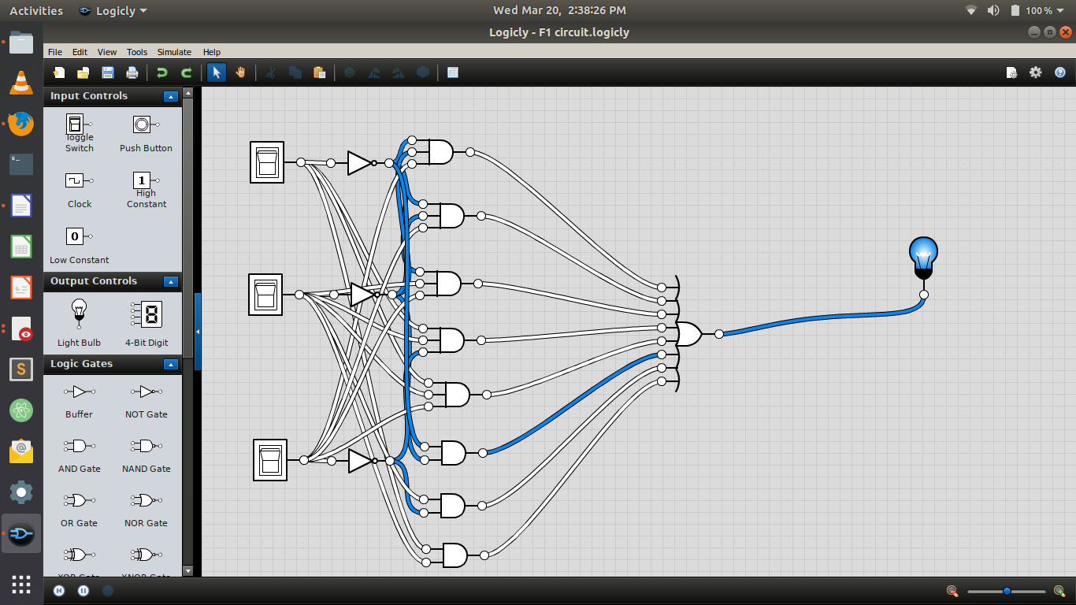
Using Nand Gate:-
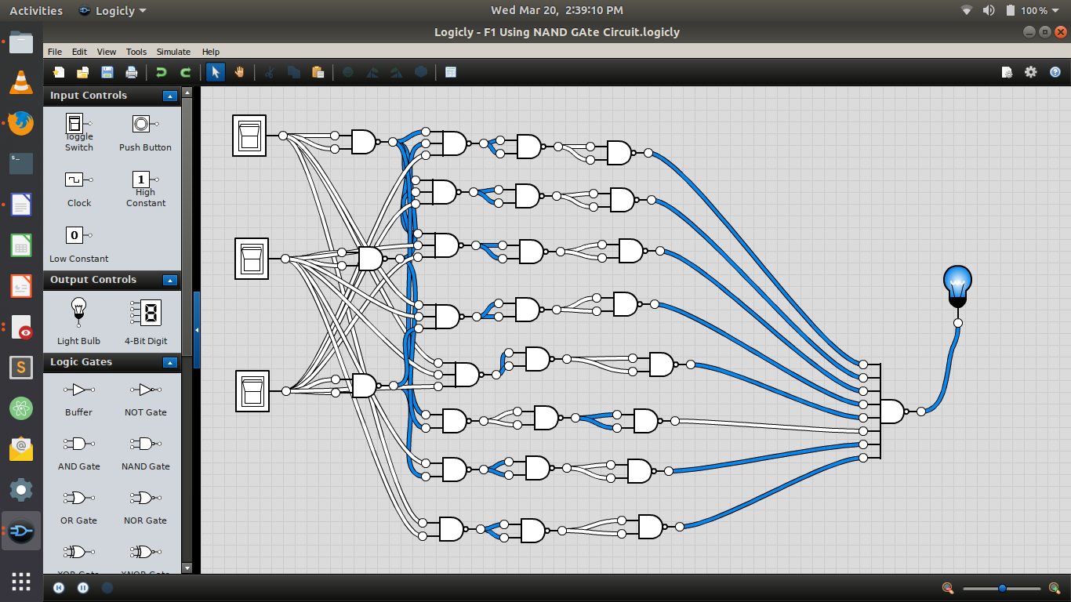

Using Nor gate:-

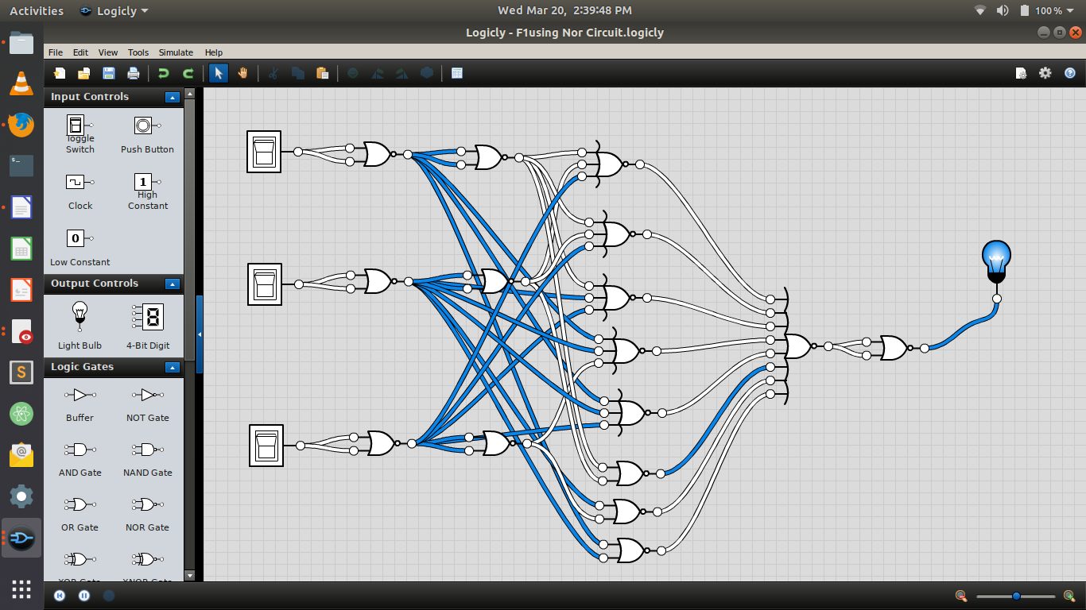

F2 = A’B’C’D+AB’C’D+A’BC’D+ABC’D+A’BCD+ABCD

Truth Table;-

A | B | C | D | F2
0 | 0 | 0 | 0 | 0
0 | 0 | 0 | 1 | 1
0 | 0 | 1 | 0 | 0
0 | 0 | 1 | 1 | 0
0 | 1 | 0 | 0 | 0
0 | 1 | 0 | 1 | 1
0 | 1 | 1 | 0 | 0
0 | 1 | 1 | 1 | 1
1 | 0 | 0 | 0 | 0
1 | 0 | 0 | 1 | 1
1 | 0 | 1 | 0 | 0
1 | 0 | 1 | 1 | 0
1 | 1 | 0 | 0 | 0
1 | 1 | 0 | 1 | 1
1 | 1 | 1 | 0 | 0
1 | 1 | 1 | 1 | 1

Circuit Diagram:-
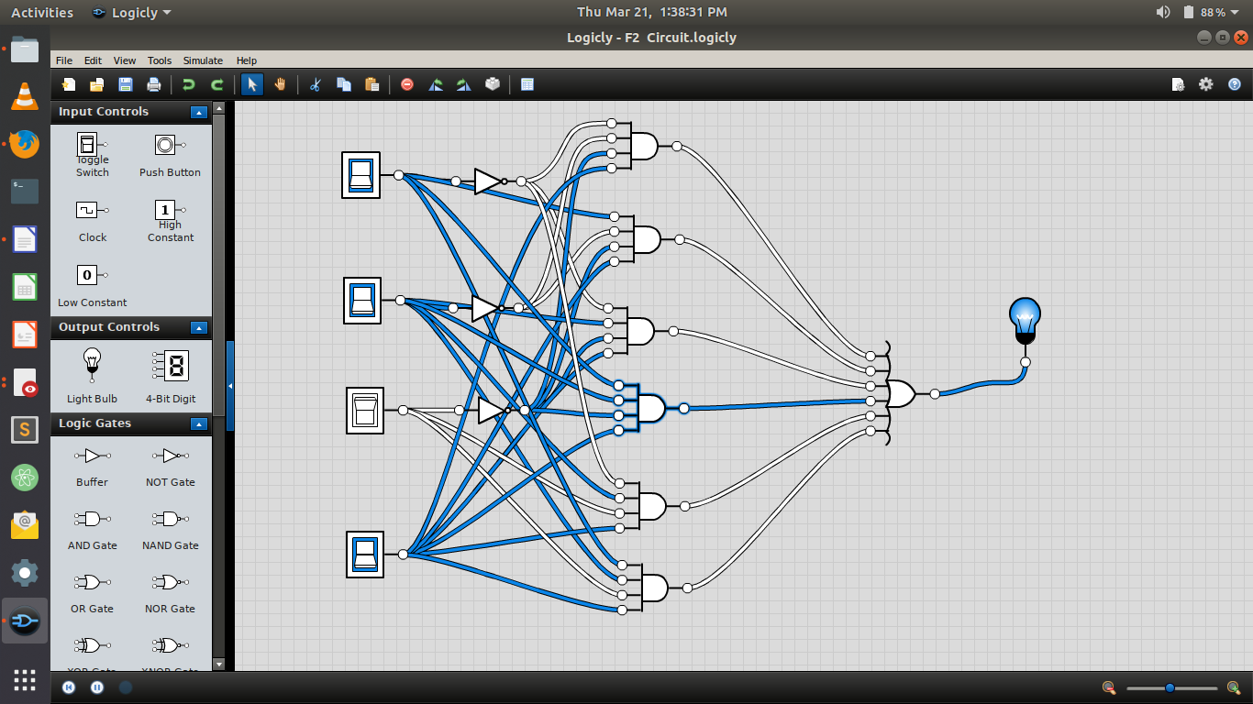

Using Nand Gate:-
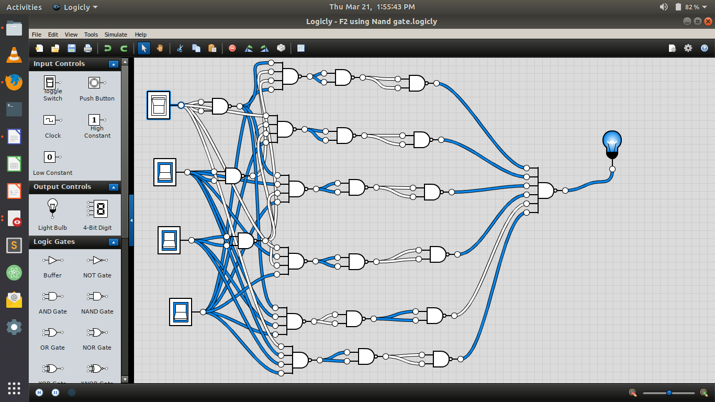
Using Nor Gate:-
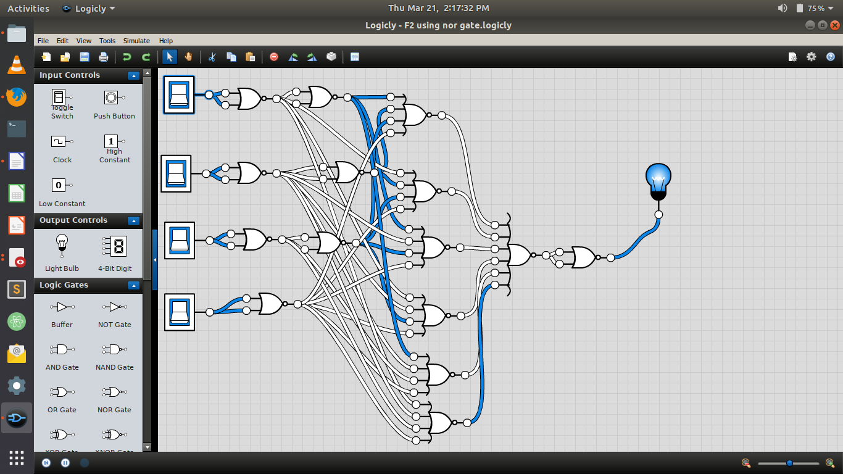

F3 = AB+A’BC’D+A’BCD+AB’C’D

Truth Table:-

A | B | C | D | F3
0 | 0 | 0 | 0 | 0
0 | 0 | 0 | 1 | 0
0 | 0 | 1 | 0 | 0
0 | 0 | 1 | 1 | 1
0 | 1 | 0 | 0 | 0
0 | 1 | 0 | 1 | 1
0 | 1 | 1 | 0 | 0
0 | 1 | 1 | 1 | 1
1 | 0 | 0 | 0 | 0
1 | 0 | 0 | 1 | 0
1 | 0 | 1 | 0 | 0
1 | 0 | 1 | 1 | 0
1 | 1 | 0 | 0 | 1
1 | 1 | 0 | 1 | 1
1 | 1 | 1 | 0 | 1
1 | 1 | 1 | 1 | 1

Circuit Diagram:-
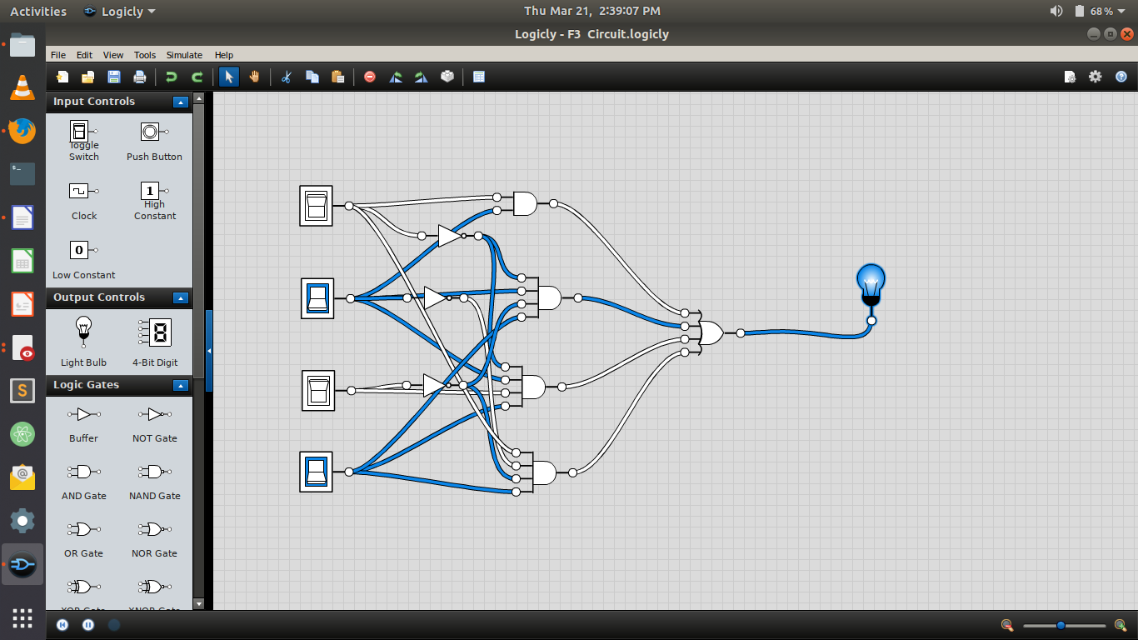
Using Nand Gate:-
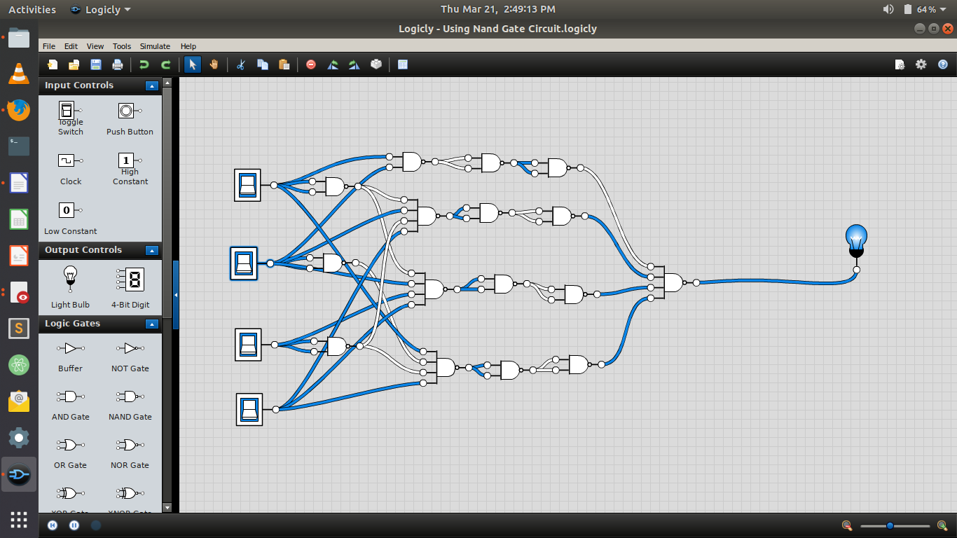

Using Nor Gate:-
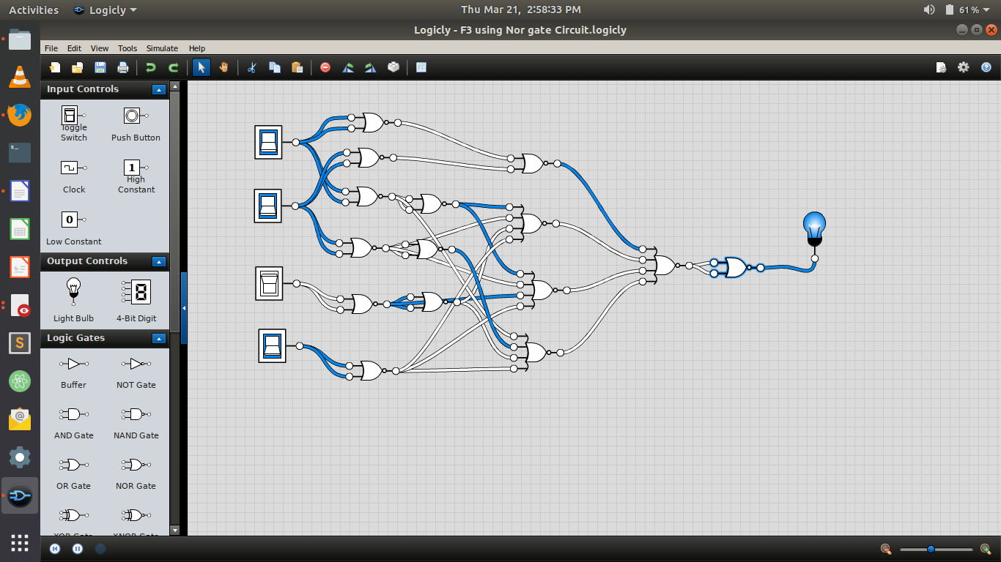

F4 = C + S where C = xy + xz + yz and S = C’ (x + y+ z) + xyz
Truth Table:-
x | y | z | F4
0 | 0 | 0 | 0
0 | 0 | 1 | 1
0 | 1 | 0 | 1
0 | 1 | 1 | 1
1 | 0 | 0 | 1
1 | 0 | 1 | 1
1 | 1 | 0 | 1
1 | 1 | 1 | 1
Circuit Diagram:-

Using Nand Gate:

Using Nor gate:

F5 = F1 + F2 (F4)

Truth Table:-

F1 | F2 | F4 | F2.F4 | F5=  F1+(F2.F4)
1 | 0 | 0 | 0 | 1
1 | 1 | 1 | 1 | 1
1 | 0 | 1 | 0 | 1
1 | 0 | 1 | 0 | 1
0 | 0 | 1 | 0 | 0
0 | 1 | 1 | 1 | 1
1 | 0 | 1 | 0 | 1
1 | 1 | 1 | 1 | 1
0 | 0 | 1 | 0 | 0
0 | 1 | 1 | 1 | 1
0 | 0 | 1 | 0 | 0
0 | 0 | 1 | 0 | 0
0 | 0 | 1 | 0 | 0
0 | 1 | 1 | 1 | 1
0 | 0 | 1 | 0 | 0
0 | 1 | 1 | 1 | 1

Circuit Diagram:-
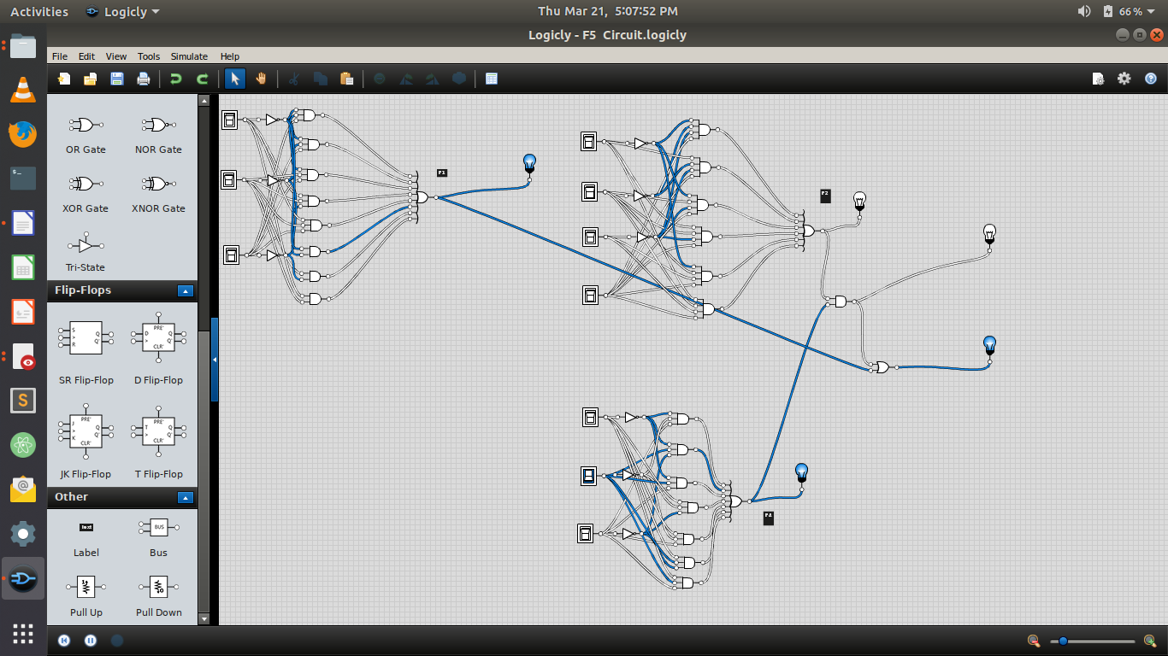
Using nand gate:-
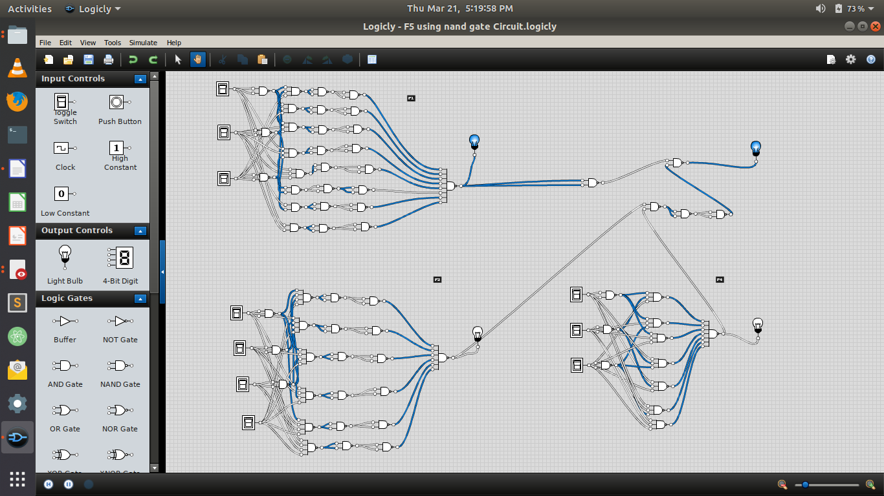
Using Nor gate:-
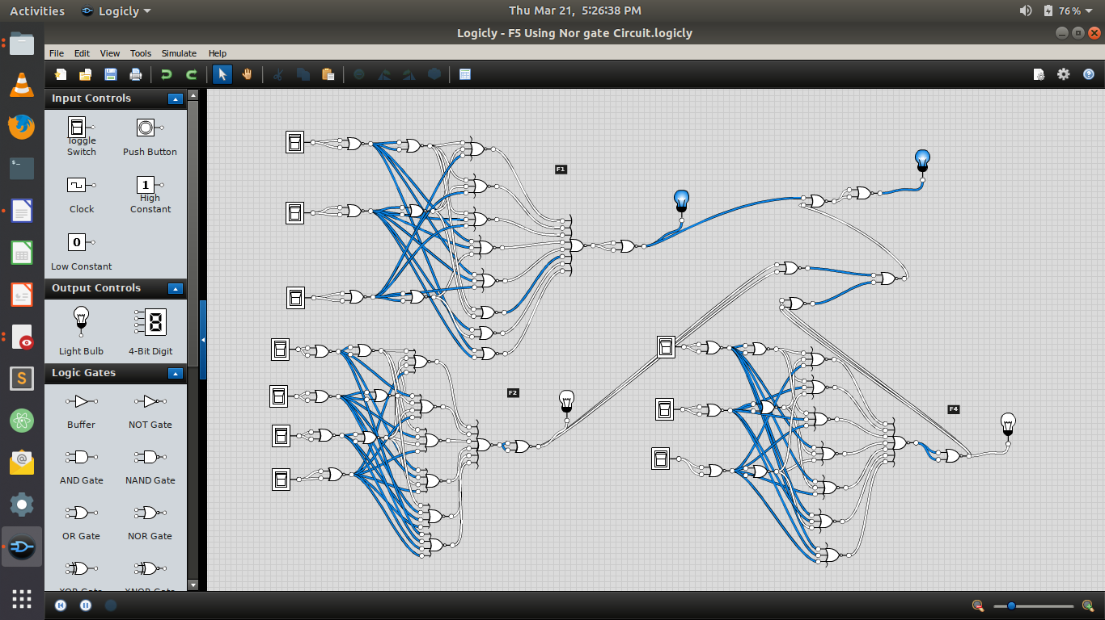
Lab 2-3:-
F1 = A’B’+AB’C+BC+AB’+C+AB’+C’+AB
1:
A | B | C | F1
0 | 0 | 0 | 1
0 | 0 | 1 | 1
0 | 1 | 0 | 1
0 | 1 | 1 | 1
1 | 0 | 0 | 1
1 | 0 | 1 | 1
1 | 1 | 0 | 1
1 | 1 | 1 | 1
2:Min term:-

Min terms = A’B’C’ + A’B’C + A’BC’ + A’BC’ + AB’C + AB’C’ +ABC’ + ABC

Max terms=No max terms in this equation.

3:Circuit Diagram:

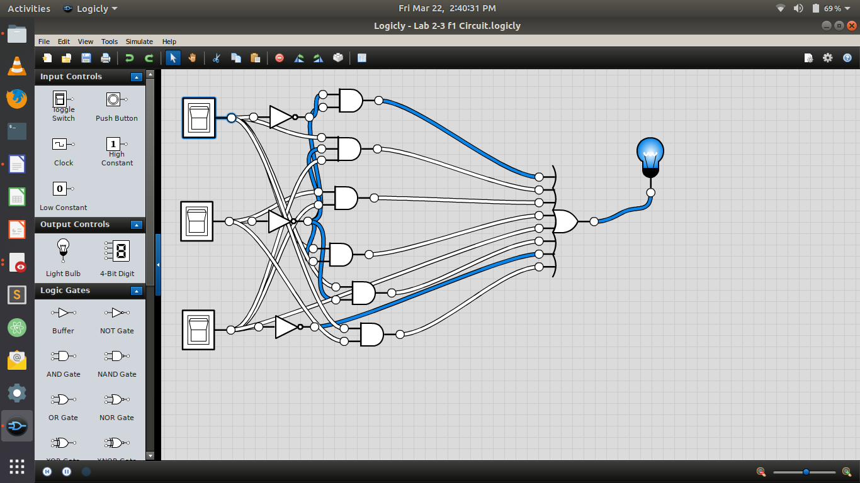

4: Circuit :

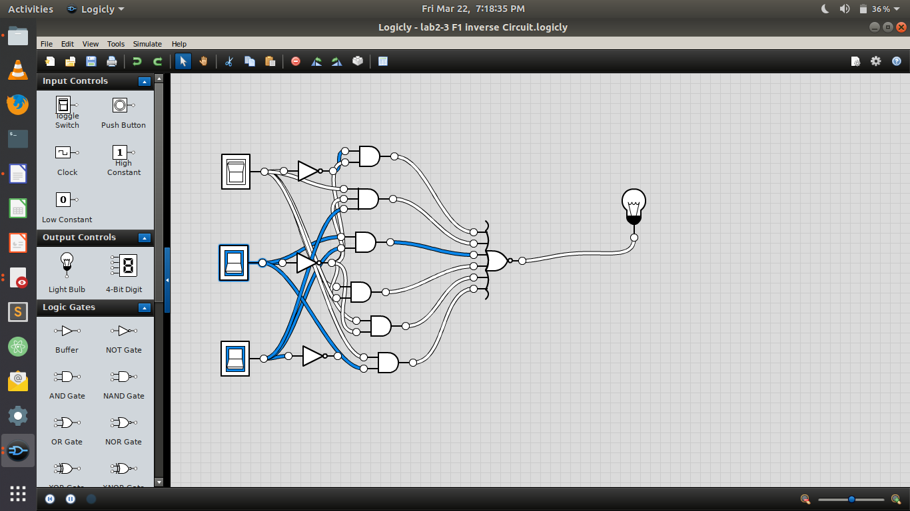

F2 = AB’C’D+ABC’+C’D+BC’D+A’B+AD
1:
A | B | C | D | F2
0 | 0 | 0 | 0 | 0
0 | 0 | 0 | 1 | 1
0 | 0 | 1 | 0 | 0
0 | 0 | 1 | 1 | 0
0 | 1 | 0 | 0 | 1
0 | 1 | 0 | 1 | 1
0 | 1 | 1 | 0 | 1
0 | 1 | 1 | 1 | 1
1 | 0 | 0 | 0 | 0
1 | 0 | 0 | 1 | 1
1 | 0 | 1 | 0 | 0
1 | 0 | 1 | 1 | 1
1 | 1 | 0 | 0 | 1
1 | 1 | 0 | 1 | 1
1 | 1 | 1 | 0 | 0
1 | 1 | 1 | 1 | 1

2:
Min Terms = A’B’C’D + A’BC’D’ + A’BC’D + A’BCD’ + A’BCD+ AB’C’ D+ AB’CD + ABC’D’ + ABC’D + ABCD

MaX Terms = (A+B+C+D) (A+B+C’+D)(A+B+C’+D’)
(A’+B+C+D)(A’+B+C’+D)(A’+B’+C’+D)

3:Circuit Diagram:

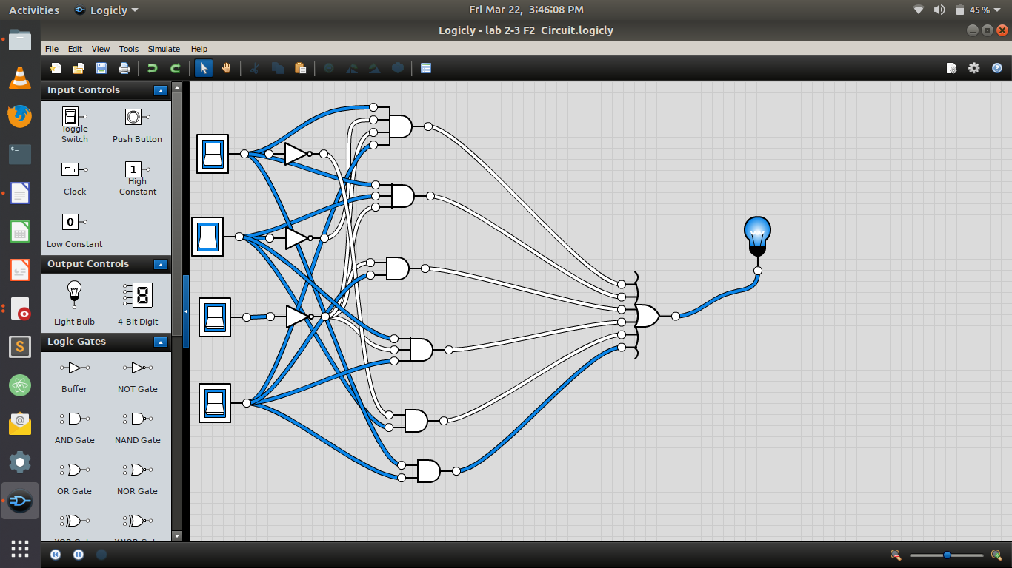

Pos:

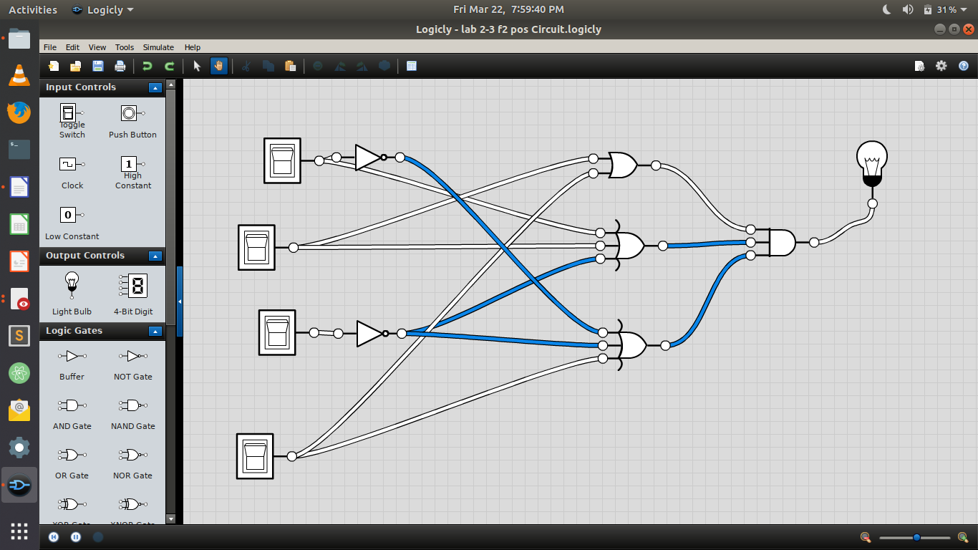
4:Circuit :
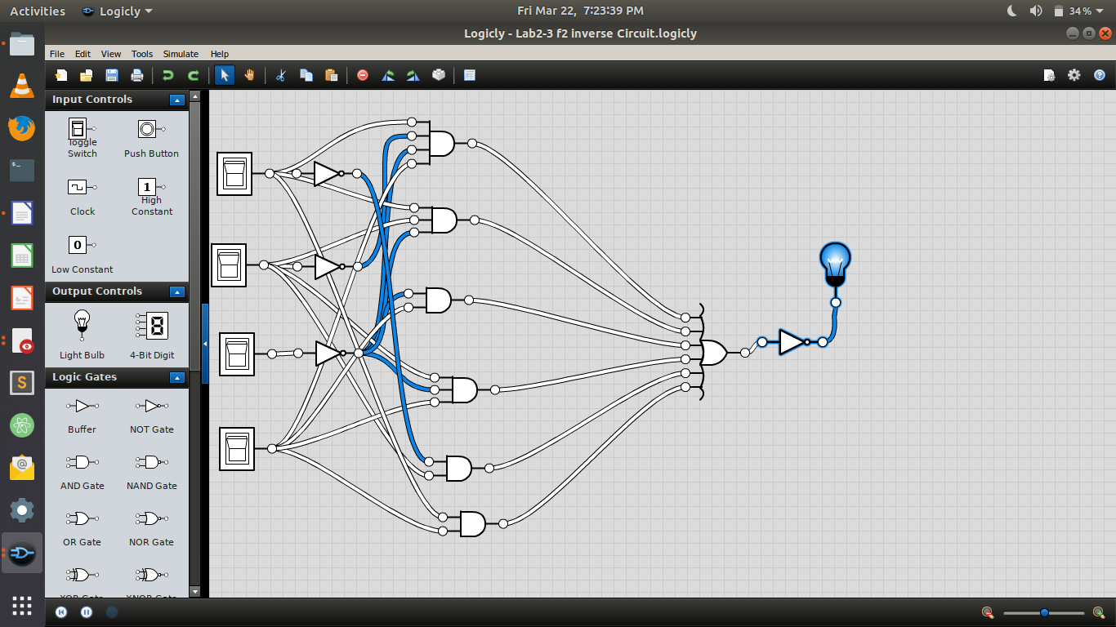

F3 = AB+A’B’D+A’B+AB’C’D
1:

A | B | C | D | F3
0 | 0 | 0 | 0 | 0
0 | 0 | 0 | 1 | 1
0 | 0 | 1 | 0 | 0
0 | 0 | 1 | 1 | 1
0 | 1 | 0 | 0 | 0
0 | 1 | 0 | 1 | 1
0 | 1 | 1 | 0 | 0
0 | 1 | 1 | 1 | 1
1 | 0 | 0 | 0 | 0
1 | 0 | 0 | 1 | 1
1 | 0 | 1 | 0 | 0
1 | 0 | 1 | 1 | 0
1 | 1 | 0 | 0 | 1
1 | 1 | 0 | 1 | 1
1 | 1 | 1 | 0 | 1
1 | 1 | 1 | 1 | 1

2:
Min Terms =A’B’C’D+A’B’CD+A’BC’D’+A’BC’D+A’BCD’
A’BCD+AB’C’D+ABC’D’+ABC’D+ABCD’+ABCD

Max Terms = (A+B+C+D)(A+B+C’+D)(A’+B+C+D)
(A’+B+C’+D)(A’+B+C’+D’)

3:Circuit diagram

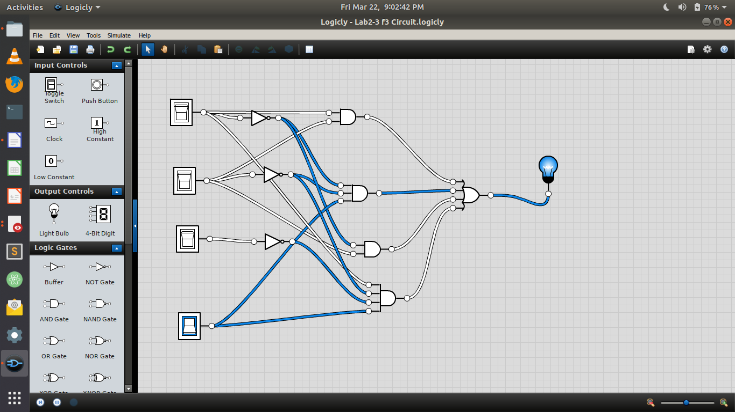

4:Inverse:
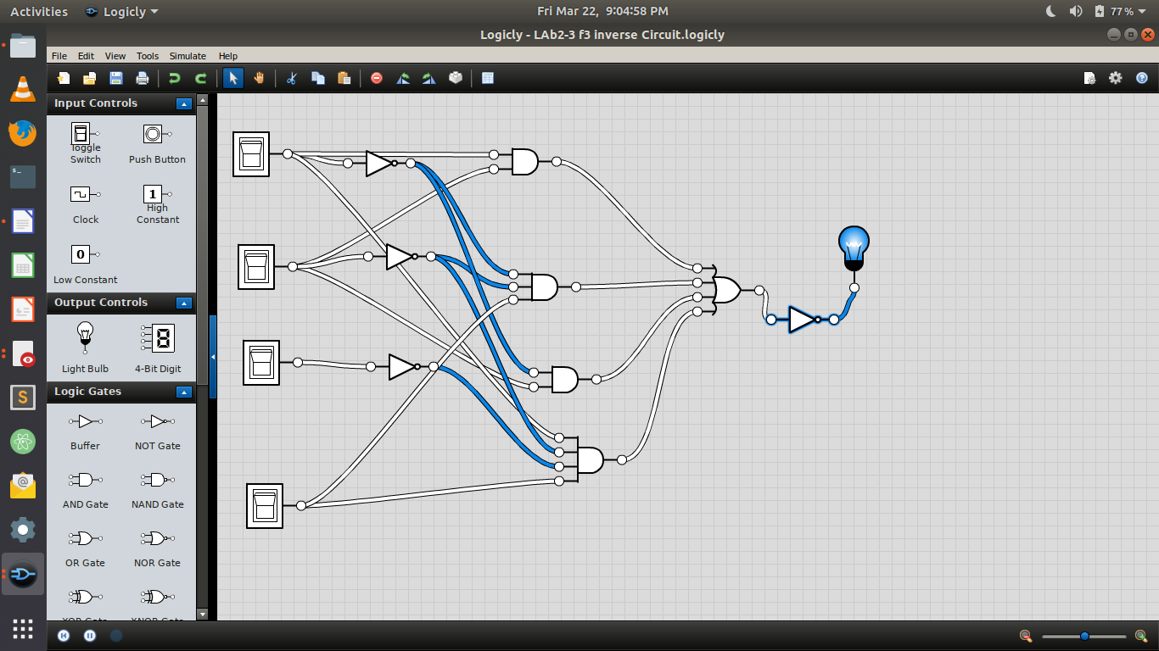

F4 = C + S where C = xy + yz and S = C’ (x + y) + xyz

x | y | z | F4
0 | 0 | 0 | 0
0 | 0 | 1 | 0
0 | 1 | 0 | 1
0 | 1 | 1 | 1
1 | 0 | 0 | 1
1 | 0 | 1 | 1
1 | 1 | 0 | 1
1 | 1 | 1 | 1
2:

Min Terms = x’yz’+x’yz+xy’z’+xy’z+xyz’+xyz

Max Terms = (x+y+z)(x+y+z’)

3:Circuit Diagram:

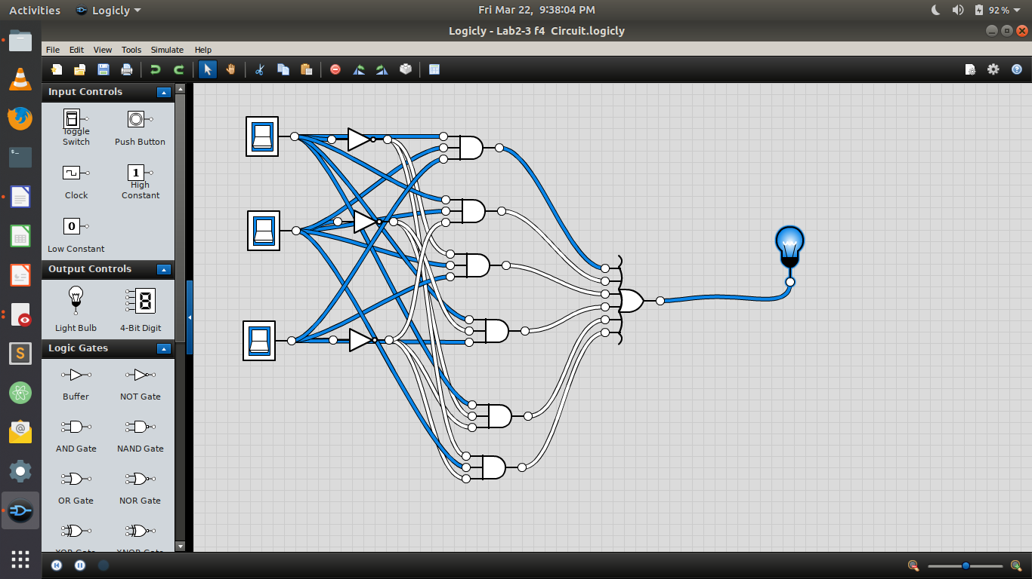

4:Inverse:

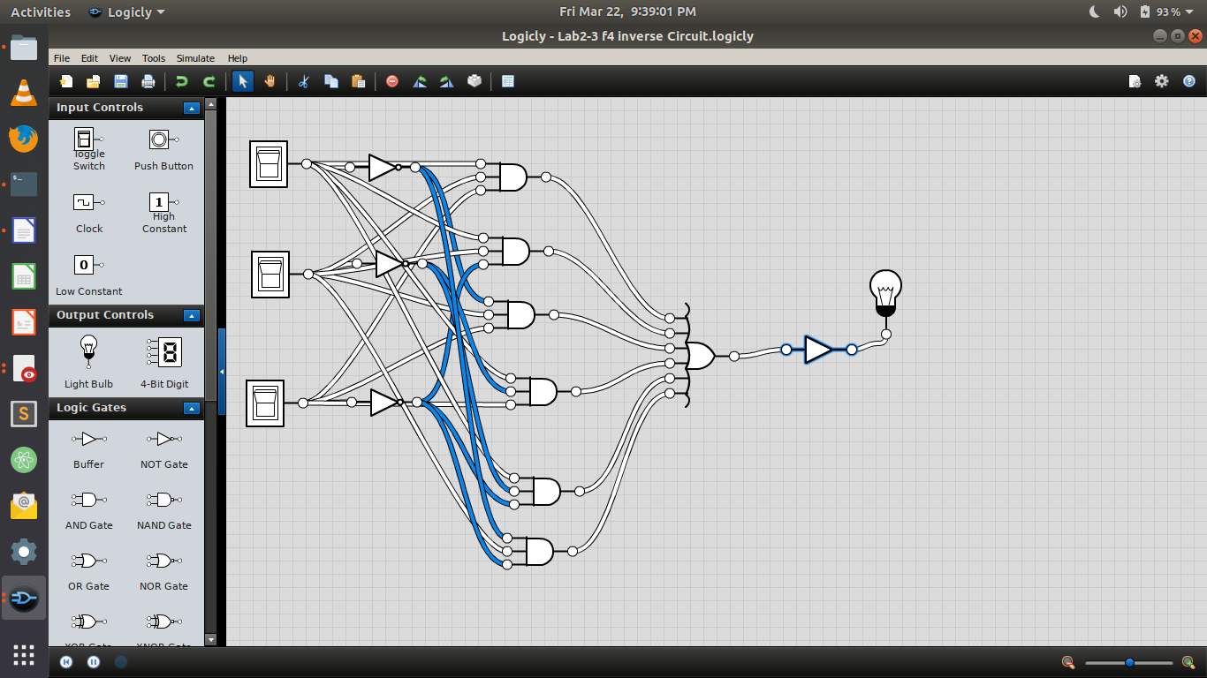

Lab 4-5:

F1 = A’B’+AB’C+A’BC+AB’+C+AB’+C’+AB

1:

A | B | C | F1
0 | 0 | 0 | 1
0 | 0 | 1 | 1
0 | 1 | 0 | 1
0 | 1 | 1 | 1
1 | 0 | 0 | 1
1 | 0 | 1 | 1
1 | 1 | 0 | 1
1 | 1 | 1 | 1

2:

K-Map:

A\BC | 00 | 01 | 11 | 10
0 | 1 | 1 | 1 | 1
1 | 1 | 1 | 1 | 1

Equation is :1
3:Using two level nand :

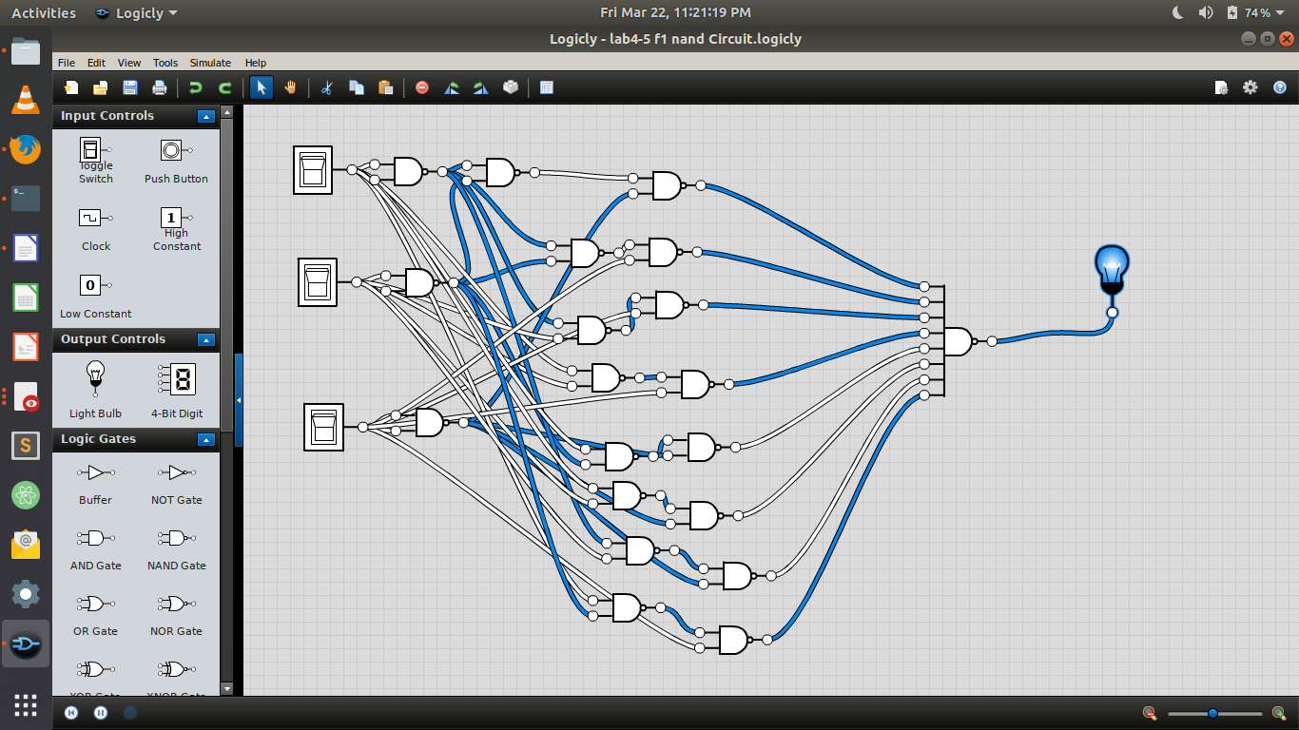

F2 = AB’C’D+AC’D+C’D+C’D+A’B+AD
1:

A | B | C | D | F2
0 | 0 | 0 | 0 | 0
0 | 0 | 0 | 1 | 1
0 | 0 | 1 | 0 | 0
0 | 0 | 1 | 1 | 0
0 | 1 | 0 | 0 | 1
0 | 1 | 0 | 1 | 1
0 | 1 | 1 | 0 | 1
0 | 1 | 1 | 1 | 1
1 | 0 | 0 | 0 | 0
1 | 0 | 0 | 1 | 1
1 | 0 | 1 | 0 | 0
1 | 0 | 1 | 1 | 1
1 | 1 | 0 | 0 | 0
1 | 1 | 0 | 1 | 1
1 | 1 | 1 | 0 | 0
1 | 1 | 1 | 1 | 1

2: K-map:

AB\CD | 00 | 01 | 11 | 10
00 |  | 1
01 | 1 | 1 | 1 | 1
11 |  | 1 | 1
10 |  | 1 | 1

Simplify:

F2=C’D+A’B+AD+BD

3:Using two level Nand gate:
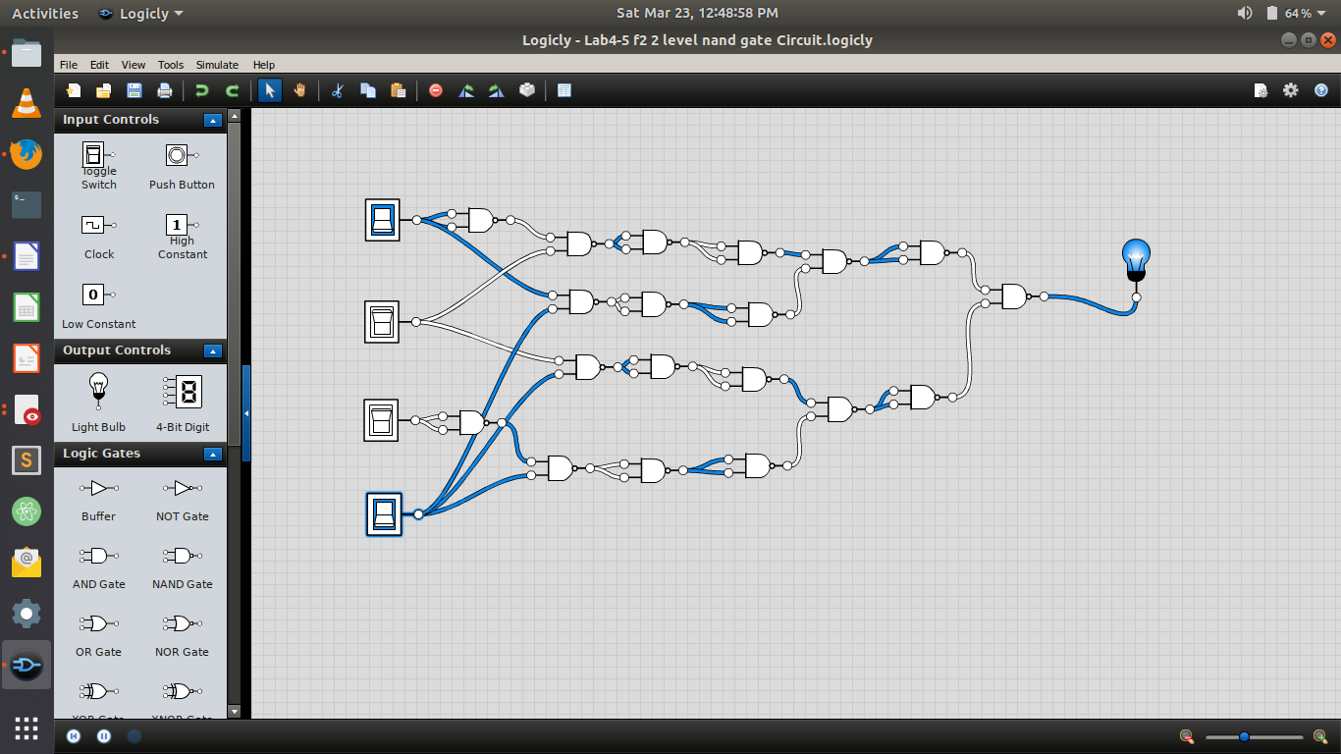
F3 = AB+A’C’D+A’BD+AB’C’
1:

A | B | C | D | F3
0 | 0 | 0 | 0 | 0
0 | 0 | 0 | 1 | 1
0 | 0 | 1 | 0 | 0
0 | 0 | 1 | 1 | 0
0 | 1 | 0 | 0 | 0
0 | 1 | 0 | 1 | 1
0 | 1 | 1 | 0 | 0
0 | 1 | 1 | 1 | 1
1 | 0 | 0 | 0 | 1
1 | 0 | 0 | 1 | 1
1 | 0 | 1 | 0 | 0
1 | 0 | 1 | 1 | 0
1 | 1 | 0 | 0 | 1
1 | 1 | 0 | 1 | 1
1 | 1 | 1 | 0 | 1
1 | 1 | 1 | 1 | 1

2:K-Map:

AB\CD | 00 | 01 | 11 | 10
00 |  | 1
01 |  | 1 | 1
11 | 1 | 1 | 1 | 1
10 | 1 | 1

Simplify:

F3=C’D+AB+BD+AC’

3:Circuit diagram
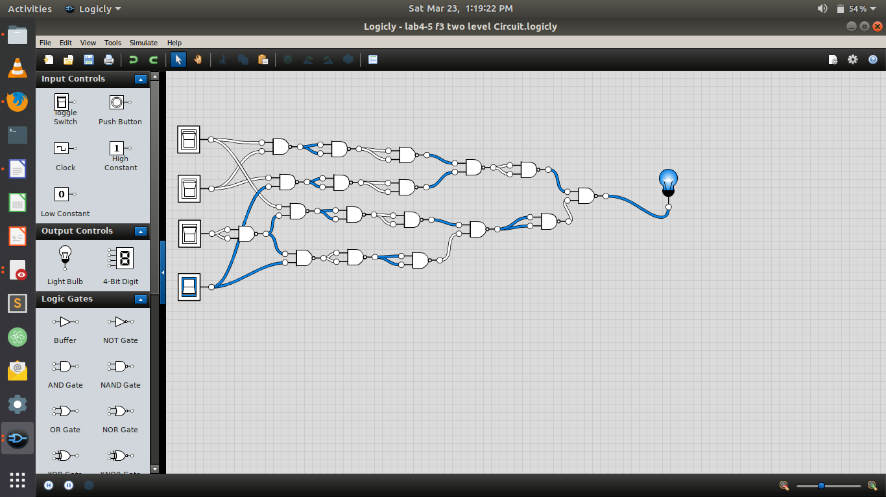

F4 = C + S where C = xy + yz and S = C’ (x + y) + xyz

1:

x | y | z | F4
0 | 0 | 0 | 0
0 | 0 | 1 | 0
0 | 1 | 0 | 1
0 | 1 | 1 | 1
1 | 0 | 0 | 1
1 | 0 | 1 | 1
1 | 1 | 0 | 1
1 | 1 | 1 | 1

2:K-map:

A\BC | 00 | 01 | 11 | 10
0 |  |  | 1 | 1
1 | 1 | 1 | 1 | 1

3:Using Two level nand gate:

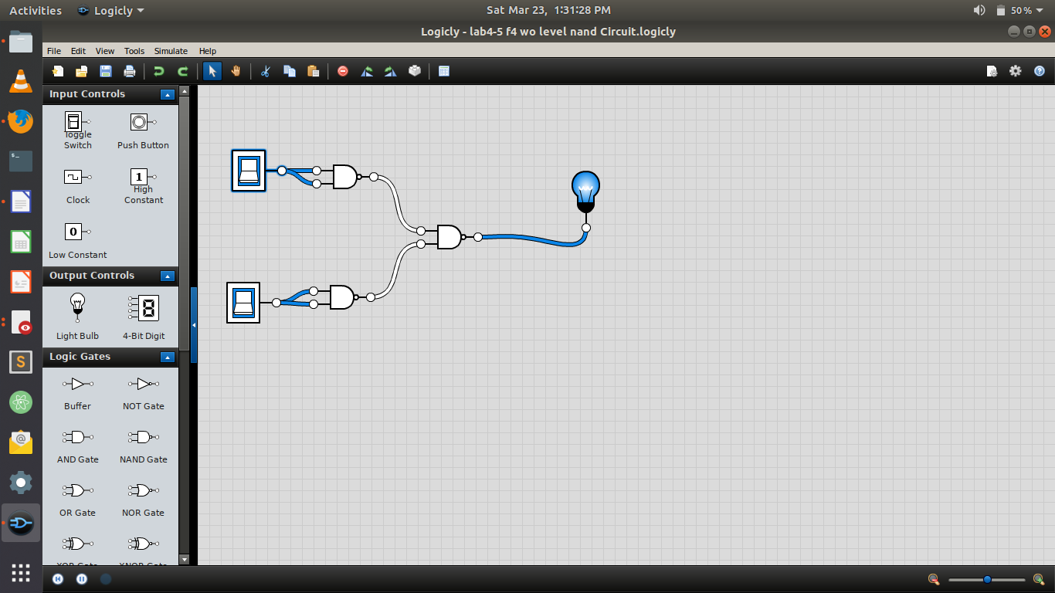

F5 = F3 + F1 (F4)
1:

F3 | F1 | F4 | F1.F4 | F5
0 | 1 | 0 | 0 | 0
1 | 1 | 0 | 0 | 1
0 | 1 | 1 | 1 | 1
0 | 1 | 1 | 1 | 1
0 | 1 | 1 | 1 | 1
1 | 1 | 1 | 1 | 1
0 | 1 | 1 | 1 | 1
1 | 1 | 1 | 1 | 1
1 | 1 | 1 | 1 | 1
1 | 1 | 1 | 1 | 1
0 | 1 | 1 | 1 | 1
0 | 1 | 1 | 1 | 1
1 | 1 | 1 | 1 | 1
1 | 1 | 1 | 1 | 1
1 | 1 | 1 | 1 | 1
1 | 1 | 1 | 1 | 1

2:K-map:

F3\F1F4 | 00 | 01 | 11 | 10
0 |  |  | 1
1 |  |  | 1 | 1

Simplify:
F5=F1.F4+F1.F3

3:Circuit Diagram:


